Task No 01:
Input:
<html>
<P> There are six levels of heading in HTML. The lower the number, the larger the header will be. Thus H1 is the largest header, and H6 is the smallest</P>
<h1> Heading 1</h1>
<h2> Heading 2</h2>
<h3> Heading 3</h3>
<h4> Heading 4</h4>
<h5> Heading 5</h5>
<h6> Heading 6</h6>
</html>

Output:
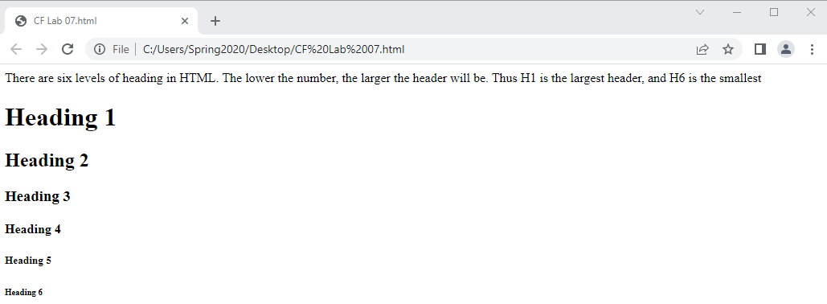
Task No 02:
Input:
<html>
<h4><center>THE CENTER TAG</center></h4>
<P><CENTER>My Name is Abdullah sadiq.</CENTER></P>
</html>
Output:
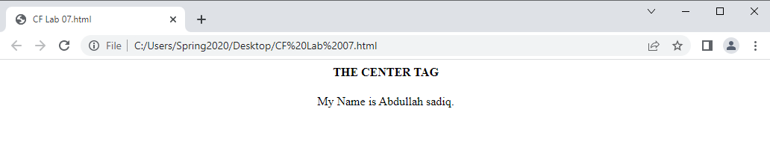
Task No 03:
Input:
<html>
<P style="color:black:50px ;All"><CENTER> All of My social Media Handles </CENTER></P>
<p><center> Click on this Link: <a href="linktr.ee/iabdullahsadiq">LinkTree</a></center></p>
</html>

Output:
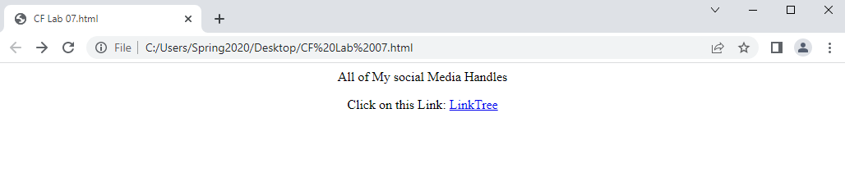
Task No 04:
- Input:
<html>
<table border="1">
<tr>
<td>Num 1</td>
<td rowspan= "2" bgcolor="green"> Num 2</td>
<td>Num 3</td>
</tr>
<tr>
<td> Num 4</td>
<td> Num 5</td>
</tr>
</table>
</html>

- Output:
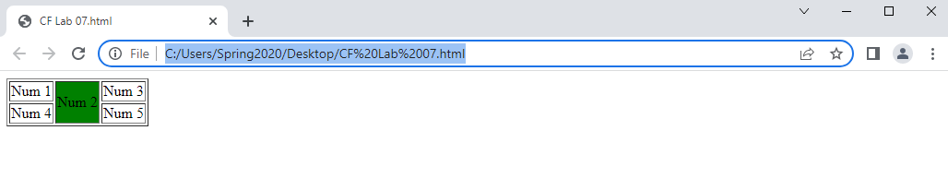
- Input:
- <html>
- <table border="1">
- <tr>
- <td rowspan= "2" bgcolor="green">Num 1</td>
- <td> Num 2</td>
- <td>Num 3</td>
- <td> Num 4</td>
- </tr>
- <tr>
- <td> Num 5</td>
- <td> Num 6</td>
- <td> Num 7</td>
- </tr>
- </table>
- </html>

- Output:
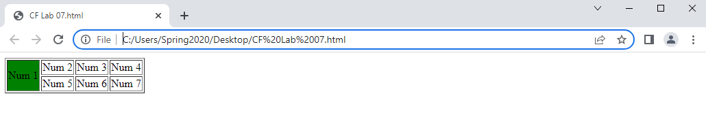
Task No 05:
Input:
Output:

Task No 06:
Input:
Output:

